

gcd(233, 360)

360 = 233 \* 1 + 127

233 = 127 \* 1 + 106

127 = 106 \* 1 + 21

106 = 21 \* 5 + 1

21 = 1 \* 21

gcd(233, 360) = 1

1 = 106 – 21 \* 5

1 = 106 – (127 – 106 \* 1) \* 5 = 106 \* 2 – 127

(233 – 127\*1) \*2 – 127 = 2 \* 233 – 3 \* 127

= 2 \* 233 – 3 \* (360 – 233\*1)

= 5 \* 233 – 3 \* 360.

Inverse of 233 modulo 360 = 5.

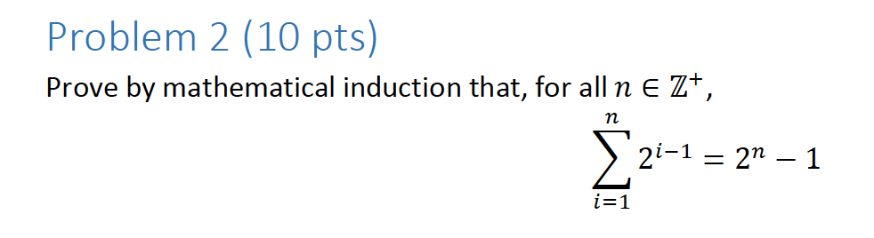

Base Case: n = 1

∑i=11 21-1 = 21-1

1 = 2-1

Thus, the base case holds.

I.H. Assume: ∑i=1k 2i-1 = 2k - 1

I.S. Prove: ∑i=1k+1 2i-1 = 2k+1 - 1

∑i=1k+1 2i-1 = ∑i=1k 2i-1 + 2k+1-1

= 2k - 1 + 2k

= 22k - 1

Base Case: k = 1

∑11 21-1 = 21-1

= 1 = 1

Thus, the Base Case Holds.

Now I will assume that ∑1k 2k-1 = 2k – 1 is true, since the Base Case holds.

Accordingly, I will plug in k+1.

Prove: ∑1k+1 2k+1-1 = 2k+1 – 1

∑1k+1 2k+1-1 = ∑1k 2k-1 + 2k+1 – 1

= 2k – 1 + 2k+1 - 1

Now we can plug in our base case.

And since we know that the first part is true (the base case) and the second part is also true, since k can be any arbitrary number, we must have that ∑1n 2i-1 = 2n-1

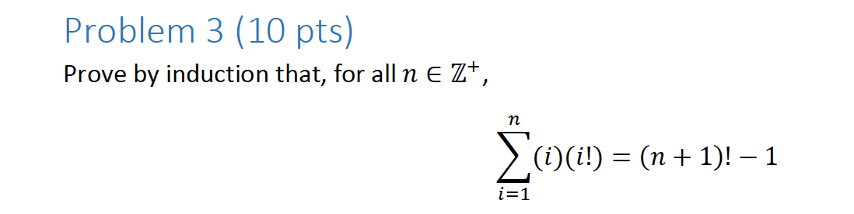

Base Case: n=1

∑i=11 (i)(i!) = (1+1)!-1

(1)(1!) = (2)! – 1

1 = 1

Thus, the base case holds.

I.H: Since the base case holds, I will assume that ∑i=1n (i)(i!) = (n+1)!-1 is true.

I.S.: Prove: ∑i=1n+1(i)(i!) = ((n+1)+1)! – 1 = (n+2)! - 1

∑i=1n+1(i)(i!) = ∑i=1n(i)(i!) + (n+1)(n+1)!

∑i=1n+1(i)(i!) = (n+1)! – 1 + (n+1)(n+1)!

= (n+1)! + (n+1)!(n+1) – 1

= (n+1)!(1 + n + 1) – 1

= (n+1)!(n+2) – 1

= (n+2)! – 1.

Thus, according to our base case, and the fact that this holds for k+1, the premise that ∑i=1n (i)(i!) = (n+1)!-1 must be true!

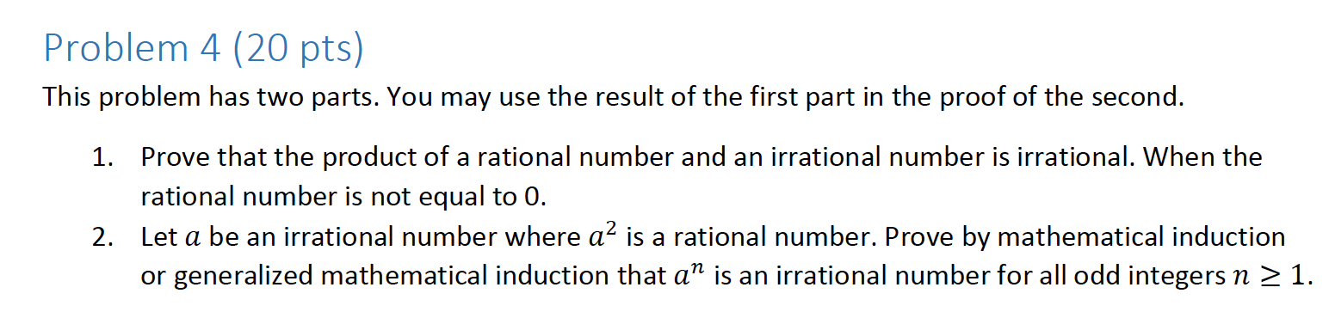

Proof by Contradiction:

Assume that the product of a rational number and an irrational number is rational. A rational number means a number that can be written as some fraction a/b.

This means that it can be written as follows.

a/b (x) = c/d.

x = cb / ad

And since cb / ad is a rational number, this contradicts the idea that the product of a rational number and irrational number is rational.

1. I will use Generalized Induction - Let a = π.

Base Case: n = 1 – must be an irrational number for a^n.

π^1 = π, and π is irrational.

π^3 = π \* π \* π, and since our proof in step 1 proves that the product of a rational number and an irrational number is rational, it holds that the product of an irrational number and an irrational number is irrational, because of the contrapositive.

Thus, π^3 is irrational.

I.H. Assume ak is an irrational number, k>=1, for all odd k.

I.S. Prove ak+1 is an irrational number, k>=1, for all odd k.

ak+1 = aka.

Well, we know based on our inductive step, that ak is an irrational number, and based on our proof from number 1, we know that the product of two irrational numbers is irrational.

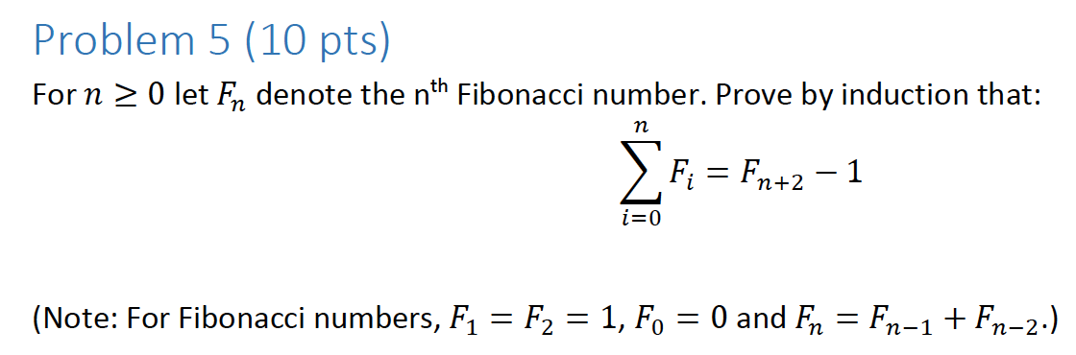

Base Case:

N = 0

∑i=0n F0 = F2 – 1

0 = 1 – 1

Thus, the base case holds.

Since the base case holds, we will assume that this is true for all n, and then use that to prove this is true for all n+1.

I.H. Assume: ∑i=0n Fi = Fn+2 - 1.

I.S. Prove: ∑i=0n+1 Fi = F(n+1)+2 - 1.

We know that ∑i=0n+1 Fi = ∑i=0n Fi + Fn+1.

Prove: ∑i=0n Fi + Fn+1 = F(n+3) - 1.

Now I will plug in my assumption.

Fn+2 - 1 + Fn+1 = Fn+3 – 1.

Thanks to the small note that Sean gave us, we also know that Fn = Fn-1 + Fn-2.

Accordingly, Fn+3 = F(n+3-1) + F(n+3-2) = Fn+2 + Fn+1.

So I will plug in Fn+3.

Fn+2 - 1 + Fn+1 = (Fn+2 + Fn+1) – 1.

And since this holds true by the communative property, the premise that ∑i=0n Fi = Fn+2 – 1

must hold!

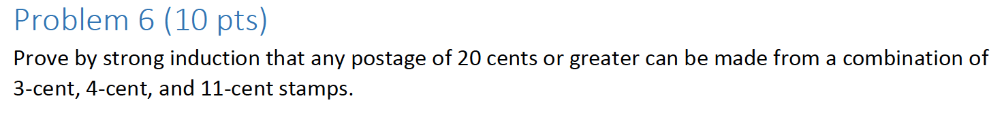

Observation: If I want to show P(k+1) is true (I can make postage of k+1 cents with these denominations of stamps, then if I just knew P(k-2), I can add a three-cent stamp, and call it a day.

Base Case: k = 20.

Take one 11 cent stamp, and three 3-cent stamps.

Base Case: k = 21.

Take one 11 cent stamp, two 3-cent stamps, and one 4-cent stamp.

11 = 4+4+3

I.H. Assume that P(k) is true for 20 <= k <= m, where m >= 22.

I.S. Prove: P(k+1) is true.

Since P(k-2) is true, we can add a 3-cent stamp, to get to k+1 cents of postage.